2009-02-11
Johnny Munkhammar

Speech, Moscow School of Political Studies, St Petersburg

Dear friends,

It is a pity that I was unable to join you. I hope for a later opportunity. Here are my remarks regarding reforms that can make us get out of the current economic crisis stronger.

Please visit www.munkhammar.org for any further information and don’t hesitate to contact me if you have questions.

In order to talk about what to do, I think one also has to deal with the issue of how we got here, how the problems started.

And we have to see what is not wrong. We don’t want to flush out the baby with the bathing water!

Background

The world has seen 25 years of great global development, both economically and thus socially.

Global economic growth and decreasing poverty

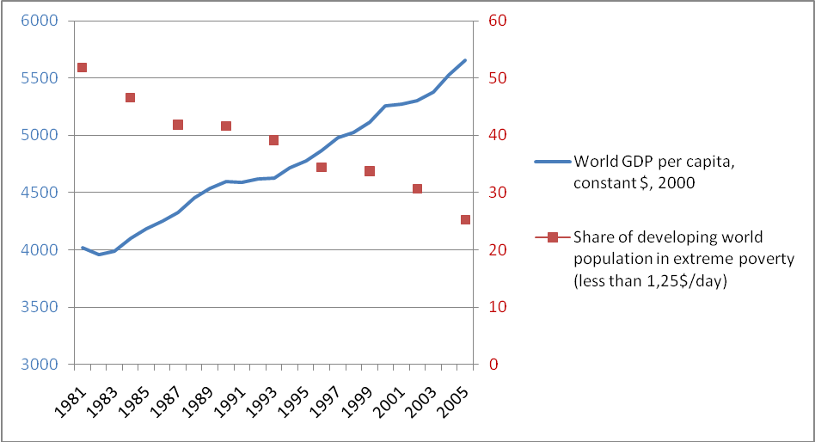

During the past quarter of a century, global GDP per capita has thus increased by 50 per cent, and that is a time when global population has also increased substantially.

The number of people living in extreme poverty throughout the world has been cut in half at the same time. Growth is essential to cut poverty.

Countries that were liberated from Communism and centrally planned economy have boomed:

- Eastern and Central Europe have had twice the growth rates of Western Europe during the past 15 years. Incomes are up and poverty rates have decreased sharply there too.

Average income levels in Central and Eastern Europe

- Russia has had an impressive economic development. Incomes have doubled during the past decade. The number of registered companies increased from 1 million in 1994 to 5 million now. 65 % of GDP comes from private enterprises.

We can see this in our daily lives. Better cars, new clothes, warm homes, DVD:s, foreign travelling, nicer food.

A wave of freedom has swept over the world. More countries than ever became democracies, though there have been setbacks.

But the world has seen increased economic freedom. That is, society has a lot of opportunity for free and voluntary transactions: Trade, invest, work, start business, etc.

Economic freedom is the opposite to central planning. The degree of economic freedom is measured annually in 160 countries in the Index of Economic Freedom (Wall Street Journal/Heritage Foundation).

There is a clear correlation between economic freedom and economic prosperity. With higher degrees of economic freedom come higher degrees of GDP – thus incomes and prosperity.

Degree of Economic Freedom and GDP
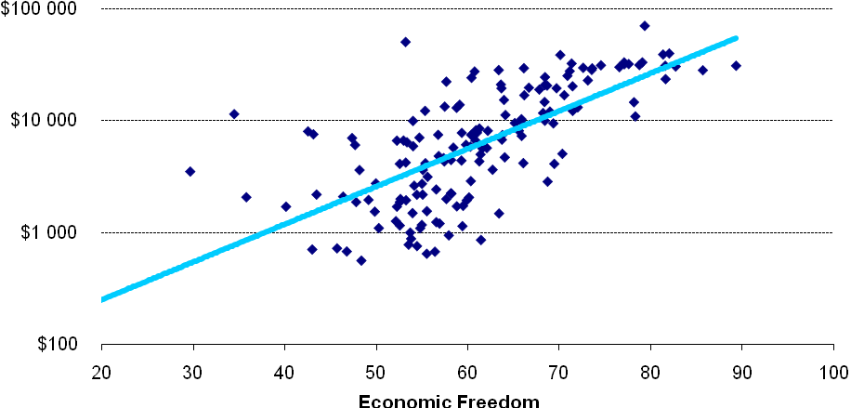

Economic freedom is about things like few regulations, low taxes, limited government, freedom to compete and mobility in the labor market. But it also concerns freedoms between countries.

During the past 25 years, we have had not only economic freedom within countries, but also between them – globalization. International trade is five times bigger than it was 25 years ago.

And globalization – spreading economic freedom – brings prosperity. The most open developing countries had a growth rate at 5 % annually during the 1990s, and the protectionist ones had -1 % growth annually.

And the world’s most globalised countries – Singapore, Hong Kong, the Netherlands, Switzerland, the US, Denmark and Canada – are the richest.

But history did not end. It returned with the financial crisis.

Crisis

Some think that it is a crisis caused by the free market. Some say Karl Marx was right. Some say that we should roll back economic freedom.

This is completely wrong. The crisis is not primarily a failure of markets – it is to a large extent a failure of politics.

The financial crisis has its origins in the US. Well-meaning policies aimed at increasing home owning, particularly among groups of people who normally could not afford it.

Fannie Mae and Freddie Mac – two companies founded by the US government, then sold but still used as government agencies – lend money to people with low creditworthiness. Laws forced private banks to do the same.

That was sub-prime loans. In 2007, they amounted to 1 300 billion dollars!

Add to this an interest rate at 1 % from the Fed for two years, 2001-2003.

And add to it a huge pile of Chinese money in so-called Sovereign Wealth Funds waiting to be invested somewhere.

Money poured into homes. And home owning increased. House prices soared.

Experts warned for years that this was unsustainable. Few politicians cared to act. Bill Clinton expanded these programs. George W Bush talked about the ownership society, though he wanted an oversight of Fannie Mae and Freedie Mac.

Then there was an economic downturn, as there always will be. And many people, who had low creditworthiness, couldn’t pay. 1300 billion dollars lost?

But who actually owned the debts? New financial instruments had packed and re-packed these so the whole world was affected.

Lehmann Brothers failed and trust was gone. Banks wouldn’t even lend to each other.

Governments caused the problem, but markets spread it around.

The economic downturn turned into a recession. We will always have economic downturns, but government interventions – in the housing market, and too low interest rates – caused the recession.

Now governments have bailed out financial institutions, at great costs. Many governments are now bankers too.

Bail-outs can be done in good or bad ways. The good ways include seeing to it that taxpayers get their money back. And that after bail-out comes pull-out. Governments are no good bankers in the long run.

And in the mean-time, when they own banks, they should appoint independent boards.

The so called real economy is now in trouble. GDP falls in the US and in many European countries. Millions of people will have to quit their jobs.

Bad solutions

Many industries want government money. The car industry has received a lot, in the US, France, Sweden, etc.

But their situation just reflects the market. We have a global shift in production where a lot of manufacturing is going to Asia. No subsidies in the world can change that.

This is creative destruction. What we produce today is not the same as yesterday. In fact, most products today didn’t exist half a century ago.

Every successful and creative economy has to let the old go. Otherwise, we will not get the new – which is usually better paid. We go from agriculture to industry to services. What we have to do is see to it that the new companies, products and jobs can emerge.

The developed world is now desperate to keep the old. Government deficits explode (and too much lending was part of creating the crisis).

There are calls for ever more subsidies, If you give to one industry, all the others will be begging.

That way, it will never end. For example, part of President Obama’s stimulus plan goes to performing arts. Why? “Because they have jobs too.” With that principle, soon everyone will be paid by government.

Subsidies and trade barriers. That is what many call for.

That is a certain way of repeating the depression of the 1930s – with its sharply decreasing trade, worsening crisis, social unrest and support for political extremists.

What we have to do is to focus on steps that will make us stronger as we get out of the crisis.

I feel like Dr No. There are many things to say no to:

No major subsidies. No trade barriers. No very low interest rates for long.

Good solutions

But there are things to do as well. There are no short-term solutions, no quick fix. But there are structural reforms that we have known for a long time will have long-term positive impact:

- Push for freer global trade. If ever the Doha round should be completed, it is now. We need not only to free up trade in goods, but also in services. And opening up agriculture for the global market will solve many problems, not least making free trade more feasible.

- Better financial regulation. The world needs free financial markets, their relative freedom has been essential in the growth of the past 25 years. But they also need regulation, for example concerning transparency.

- De-regulations for entrepreneurs. If we want the new companies, products and jobs to emerge, we have to make it easy for entrepreneurs. Today, they have to devote weeks every year to government bureaucracy – and to pay heavy taxes.

- Flexible labor markets. We can only protect old jobs temporarily, at a high cost. If there is no demand for the products, they cannot remain. The old jobs must go, but people must be mobile and be able to get to the new jobs.

- Adaptable education systems. Sometimes, people have to acquire new skills to be able to get into a new job. Education systems must be flexible. And private manning companies like Manpower can help a lot.

- Open up the services sector and welfare services. In the Western World, this is where there is a strong demand, and willingness to pay. We just need to open them up for new entrepreneurs.

- Lower and flatter taxes. Tax systems must be simple and transparent. And in a globalised world, many countries have too high tax rates. If entrepreneurship and work shall be profitable – and that is what lifts us form the crisis – then such taxes have to be lower.

- Invest in education and R&D. All the top universities are in the US and Britain. The rest of us need to liberate higher education from government control. Governments can replace subsidies with investments in Research and Development.

Conclusion

The market economy is about freedom, and it is the engine of prosperity. That is why increasing economic freedom created a golden age.

But there will always be downturns. And economic bubbles. Gordon Brown did indeed not do away with boom and bust. But it takes governments to create a recession.

Downturns are painful. But they are in the long run only small bumps on the way to increased prosperity. For example, US GDP per capita is 19 times higher than in 1850, and figures are similar for most of Europe.

US GDP per capita 1850-2005

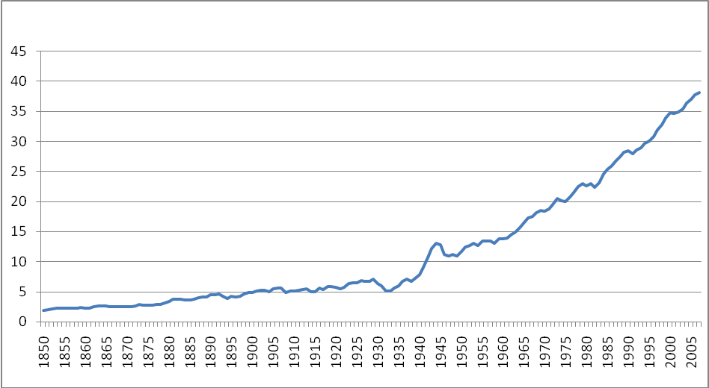

We have to make the bumps smooth to handle for people. Flexibility, openness and re-training are important parts.

Recessions can be made worse. Subsidies and protectionism are two certain ways.

We need to keep and strengthen the foundations of the free economy and reform further so we get out of the crisis stronger.

Thank you!

